Stage 3 Camp
Payment Details and Information

Wednesday 11 April, 2018

Dear Parents,

As mentione in the first information letter, our Stage 3 overnight camp this year will be taking place at the Gosford Outdoor Education Centre, Wisemans Ferry Road, Mangrove Mountain, for three days (two nights) from Wednesday June 13 to Friday June 15, 2018.

This note provides information on the final cost, payment details and medical information forms.

Costings and payment information
The cost of the Camp has been conformed as $275.00 per student. The cost of the camp covers all food, accomodation, transport, activities and staff supervision for three days and two nights.

It is expected that all students attend. If you require assistance regarding payment please contact Mr Logue (Assistant Principal) as soon as possible. More information on camp activities will follow shortly. All permission notes and information regarding the camp;
- will be sent home with students
- sent via the Skoolbag phone app (please contact the front office or visit our school home page and click on the SKOOLBAG tab) and;
- posted on the school website.

Medical information
Please find attached the medical information forms which neecto be completed for each student attending the Stage 3 Camp.

Please ensure you return the attached ‘Payment Schedule”, “Consent Form” and “Medical Information Forms “ by Friday May 4, 2018.

Sincerely,
Stage 3 Teachers
David Logue (AP), Rachel Andrew, Kylie Stafford and Charlene Kennedy
How to make an online payment
Please complete the attaced note by
Friday May 4, 2018
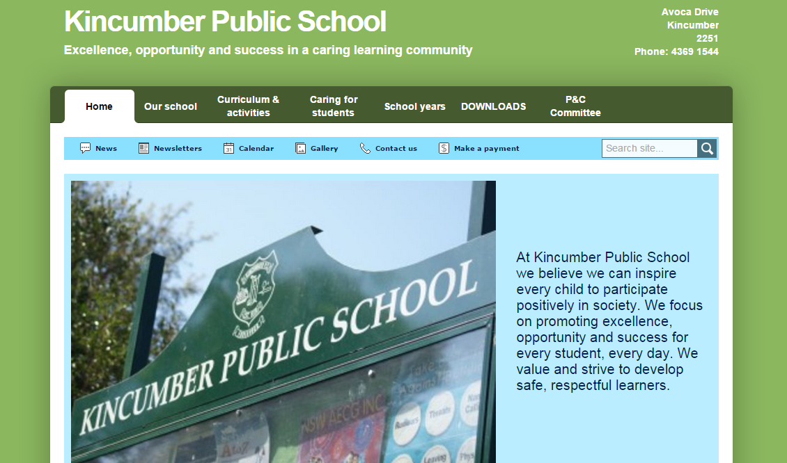
Stage 3 overnight camp– payment schedule
3. Choose ‘excursion’ and fill in payment amount details
2. Fill in the mandatory fields (*)
4. Click next to complete payment
1. Click here to make a payment

In an effort to support parents by ensuring the total cost of the excursion is paid by Friday June 1, 2018, we ask parents to complete and return to school the following payment schedule:

Student Payment schedule for _________________________________
(student name)

Cost of excursion: $275.00

Payment options (please read carefully and choose one of the following payment options):

I commit to paying the total outstanding amount in one single payment no later than Friday June 1, 2018.

or

I commit to paying the balance in instalments, completing final payments by Friday June 1, 2018.

or

I commit to follow the school schedule of instalments, paying the total cost of the camp by Friday June 1 2018. I have read the outlined schedule below:

S3 camp payments: | Amount due: | Date due: | Balance Due:  Please note: there can be no variations to this payment schedule.  Parents who commit to following this payment plan must guarantee to meet scheduled payments by agreed dates.  Skoolbag reminders will be sent on the dates listed.
Deposit: | $75.00 | Friday April 6, 2018 | $200 remaining
First insalment: | $75.00 | Friday May 4, 2018 | $125  remaining
Second instalment: | $75.00 | Friday May 18, 2018 | $50  remaining
Third instalment: | $50.00 | Friday June 1, 2018. | $0 remaining
This sheet must be completed and returned by Friday May 4, 2018.

