Sight Word Games
Hi Families,
Starting this term, teachers will be sending home cards with the words your children have been learning in class on them. We have put together a short list of fun games that you may wish to play with your children at home. These games are meant to be fun and easy for your child to play. Once children are familiar with the game, they may even like to run it themselves ‘as the teacher’ and quiz you!
There are many other fantastic ideas online. You can find them using sites such as Google and Pintrest. There are many more ideas on this website: http://thisreadingmama.com/hands-on-spelling-activities/
If you would like more information feel free to contact your teacher. Happy playing!
Game | What you will need | What to do | Picture
Word hunt | Words written on pieces of paper | Hide the sight word pieces around a room in your house, your child can collect them and read them out. They can hide them for you to find. | 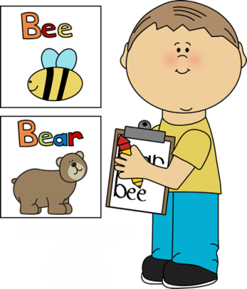
‘Write the room’ | Words written on pieces of paper, Blutac, paper | Blutac the sight words around a room in your house, your child walks around finding them and reading/writing them. Turn it into a time trial or add different actions e.g. “This time you have to jump, hop, skip to find them all”
Card games e.g. Memory match, go fish | Two copies of the words on paper | Memory match: Lay out both sets of cards face down, take turns trying to find a match, reading the words aloud as you turn them over.  Use the words to play other games such as go fish | 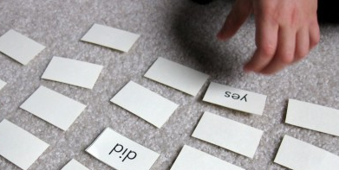
BINGO! | Paper  Pens | Write the words on a grid and also on strips of paper and play bingo! Use stickers, a stamp, finger painting, counters, coins etc to mark off the words. | 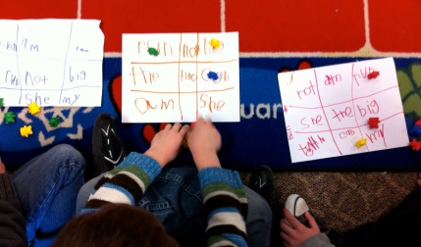
Multisensory Writing | Word list | There are lots of fun places for kids to practice writing with their fingers. Examples include in the sandpit or dirt, on the foggy shower screen, carpet. If you are feeling adventurous you can even put some paint and/or shaving foam onto a tray for them to write in. | 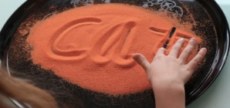  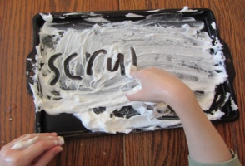
Play doh | Playdoh | Use play doh to make the words on the list. | 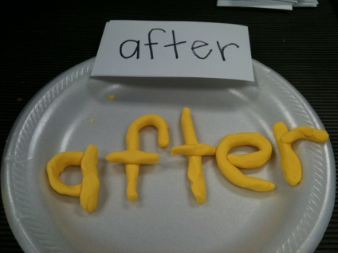
Chalk board | Chalkboard, chalk, cloth | Write the words on a chalk or whiteboard. You could write the word on the board, have the child trace over it with a damp sponge, then write it again themselves. | 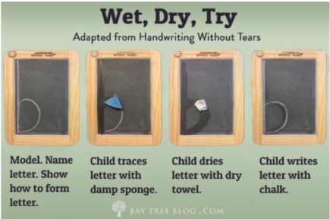
Writing UNDER the table | Paper, Blutac | Blutac your paper to the bottom of a table and write or read the sight words under the desk!
Dynamite | Paddlepop sticks or paper with the words on | Write a sight word on one end of your paddle pop sticks or pieces of paper. Write DYNAMITE! on a couple of sticks. To play, take turns drawing a stick and reading the word. For every word that is read correctly, the player keeps the stick. But if a player draws DYNAMITE!, they must put back all of their sticks. When all of the sticks have been drawn, the player with the most sticks wins. | 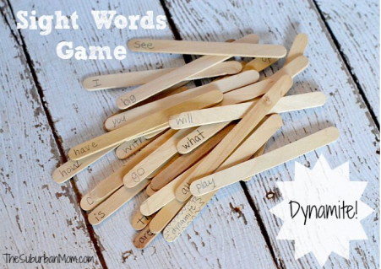
Where’s the bear? | Small toy/figurine  Cups  Blutac | Write or stick sight words on cups or bowls. Review the words with your child before hiding a bear underneath one of the cups. Have your child guess which cup they think the bear is under by reading the sight word on the cup. Mix the cups around, try to ‘trick’ them, let them trick you! | 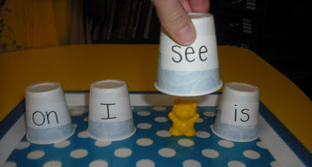
Spelling hop | Chalk | Write the alphabet on the concrete and have kids jump around to spell out the word. You can put a star for them to start and finish on and a question mark for if they need help. Have them challenge and check your spelling too. For more information on this one check out: http://deceptivelyeducational.blogspot.com.au | 