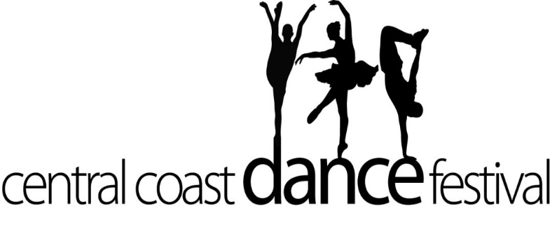
Name: ________________________
Wednesday 9 May, 2018

Dear Dancers,
Congratulations on your selection in the Central Coast Dance Festival, 2018. Over recent years, Kincumber Public School has established itself as a school of excellence in the area of dance and 2018 is no exception, with both KPS dance groups being selected to perform this year!
The Stage 3 dance group will perform in two shows, both to be held on Wednesday 4 July 2018. This is considered an honour, being selected for the final closing show of the festival. The first show starts at 6.30 pm and the second show commences at 8.15pm. All dancers will perform in both shows.

Preparation for the festival needs to be completed quickly to ensure we are ready for the dress rehearsal on Wednesday 6 June, 2018. Parents, please complete the student participation and publicity consent form to the office as soon as possible. This must be completed for every performer.

Dancers will need to provide their own costumes in a black, white and red theme. Parents are asked to use the attached costume drawing as a guide for creating costumes for their child. In the past, we have found this to be a cheaper option for parents than having costumes made/purchased or supplied. Families are encouraged to make/ source their own costumes from items at home, borrowed items or from 2nd hand shops. For girls, an adult-sized long business shirt can be easily adjusted to create the look of a ‘shirt dress’. For boys, all three main clothing pieces should hopefully be easy to source – shirts, pants and vest.

Costume: for the red cumber bund (boy) and red bandana (girls), these will need to be all the same colour and style. For this reason, dancers will be required to pay approximately $10 for material to cover this part of the costume. Please do not pay for this, at this stage, until costs are confirmed. Next week, students will receive a permission note for the dress rehearsal on Wednesday 6 June. This note will confirm the cost required for the bus to and from the theatre as well as for costs for costume material. All dancers must have a complete costume ready for the dress rehearsal at Laycock St Theatre on this day.

Information regarding ticket release dates will be passed on as soon as possible. Tickets must be purchased online or directly from Laycock St Theatre. Information on ticket release will be sent to parents via the Skoolbag app. All copies of notes will be posted on the school website “Dance Festival” page.

If you have further questions about costumes, please email me on: Karen.wardlaw@det.nsw.edu.au

I am so impressed with the diligence in practice and the commitment of all of my dancers and am so looking forward to seeing them on stage at the Central Coast Dance Festival at the end of term!

Congratulations again to our amazing dancers and the families so well supporting and encouraging them,
Karen Wardlaw
karen.wardlaw@det.nsw.edu.au
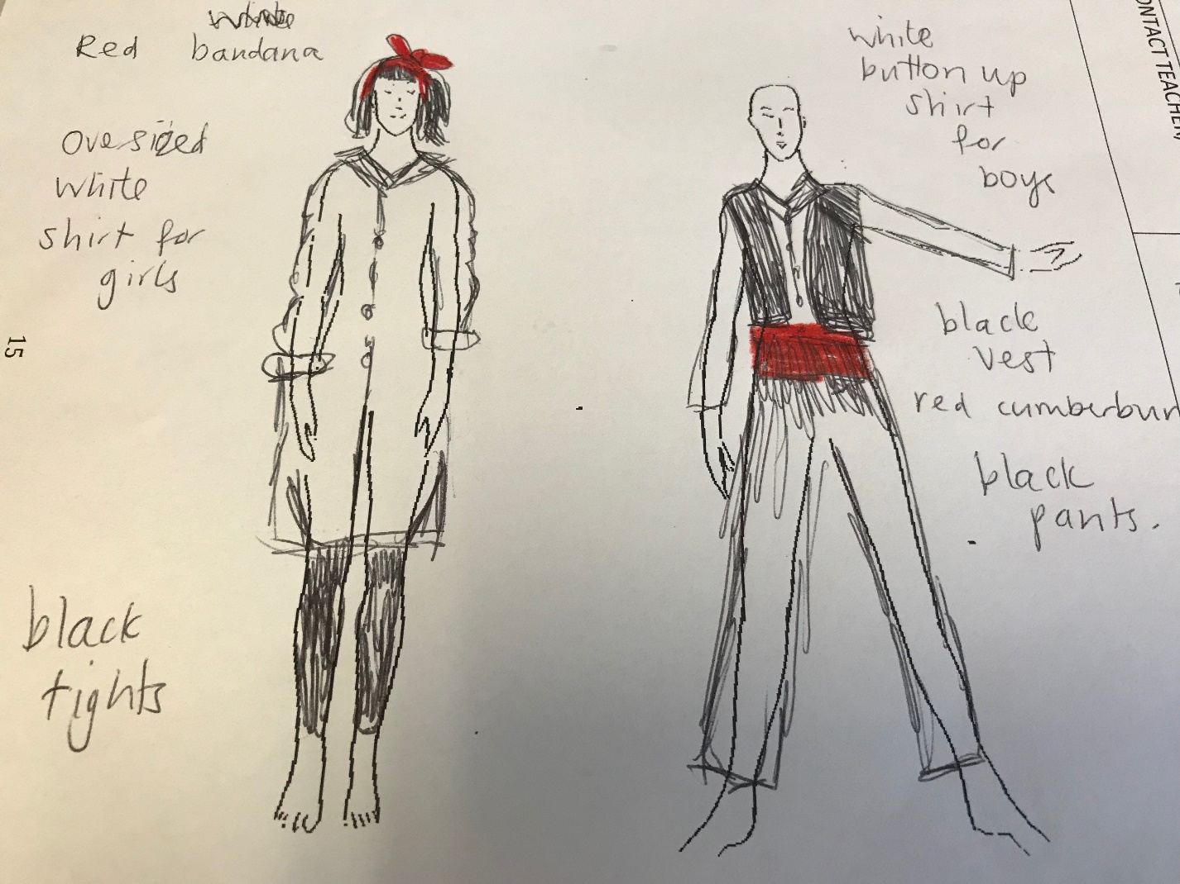

Costume info: please note the following points:
- boys ‘cumber bund’ and girls red bandana will be supplied – cost to be confirmed asap.
- No midriffs should be visible on stage under shirts
- Dancers will perform in bare feet
- More information regarding agreed hair style (for girls) and make up will be provided asap

