



Kincumber Public School

Student Enrolment

Procedures and Protocols

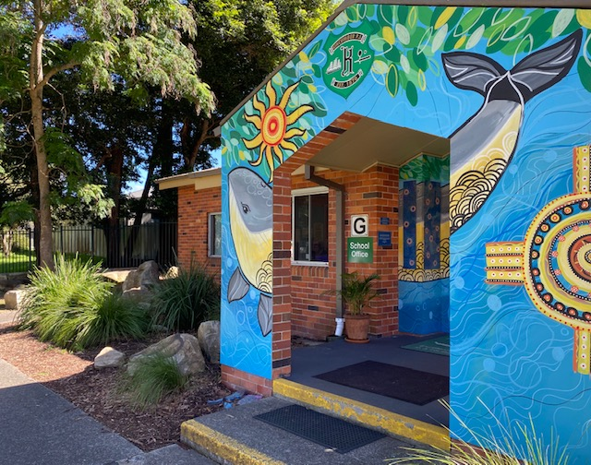Procedures and Protocols

*Insert School*

*Promotional image*

Contents

Document History 2

Synopsis 3

Managing enrolments in schools 3

Local Enrolment 3

Residential address check 4

Enrolment cap 4

Enrolment Buffer 4

Non-local enrolment 5

Criteria 5

Enrolment Panel 5

Enrolment time frame 6

Appeals 6

# Document History

|  |  |  |
| --- | --- | --- |
| Version | Author | Date |
| 1.0 | Mrs Trish Peters Principal | 9 August 2019 |

# Synopsis

This document supports Kincumber Public School’s implementation of the NSW Department of Education’s Enrolment of Students in NSW Government Schools Policy (July 2019) and should be read in conjunction with the [General Enrolment Procedures](https://education.nsw.gov.au/policy-library/associated-documents/pd-2002-0006-01.pdf).

# Managing enrolments in schools

A student is entitled to enrol at the local school that the student is eligible to attend if their home is within that school’s local intake area. Parents may apply to enrol their child in the school of their choice. Acceptance is subject to the child being eligible to attend and the school can accommodate the child. (General Enrolment Procedures: 9)

Parents may enrol a child if they turn 5 years of age on or before 31 July in that year. Students identified as gifted and talented, who are aged 4 years or older at 31 January of the year of enrolment may only be enrolled in accordance with the Gifted and Talented policy. (General Enrolment Procedures: 2)

# Local Enrolment

To determine if a student’s home is within a school’s local intake area please use the School Finder App by clicking on the button below.

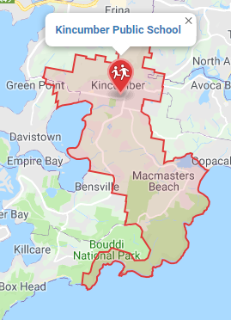

School Finder App

# Residential address check

Under the Education Act 1990, principals may require proof of address to their satisfaction in order to establish a child’s entitlement to enrol in the school. However, any requests for proof of address must be reasonable in the circumstances. Schools that are at or nearing their local enrolment buffer as calculated in accordance with sections 9.1 and 9.2 will use the following 100-point residential address check to determine the student’s entitlement to enrol at the school.

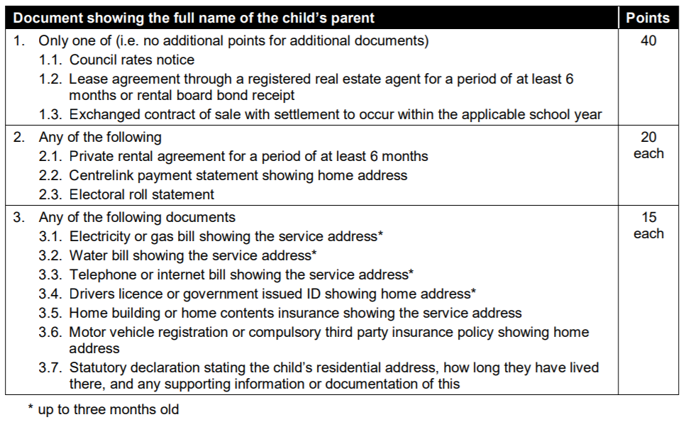

NB: Where a parent is able to give good reasons why they are unable to present documents, or in exceptional circumstances, principals may waive or vary the 100-point residential address check NSW Department of Education | PD/2002/0006/01/v1.0.0 10 requirements when assessing a child’s entitlement to enrol at the school. If this is to occur, principals are required to seek the approval of the Director, Educational Leadership.

# Enrolment cap

Enrolment cap

Buffer level

Enrolment

The Enrolment Cap for a school is established centrally based on permanent accommodation.

The enrolment cap for Kincumber Public School is 462.

(General Enrolment Procedures: 9.1)

# Local enrolment buffer

Within the enrolment cap, a number of enrolment places (the buffer) must be set aside for the enrolment of local students arriving throughout the year. The size of the buffer will differ in each school based on historical data, enrolment fluctuations and on the number of families moving into or out of the area. The size of the local enrolment buffer is set locally by the principal and approved by the Director, Educational Leadership.

It is reviewed annually and set in time for assessing applications for the following year’s enrolment intake. Places in the local enrolment buffer are not to be offered to non-local students. (General Enrolment Procedures: 9.2)

The Enrolment Buffer for Kincumber Public School is 3% (12 places in 2019).

# Non-local enrolment

Non-local enrolment applications are only considered by schools that can accommodate the child below the set local enrolment buffer level. (General Enrolment Procedures: 9.4)

Except for enrolments at the commencement of the school year, schools that have not reached their local enrolment buffer level should only accommodate non-local enrolments into classes with available places. (General Enrolment Procedures: 9.4)

Non-local enrolment applications include the [Application to enrol in a NSW Government school](https://education.nsw.gov.au/public-schools/going-to-a-public-school/translated-documents/enrolment-application) and a non-local enrolment application form. The non-local enrolment application form is developed by the school and requires the applicant to address the selection criteria and provide supporting documentation. (General Enrolment Procedures: 9.4.1)

# Criteria

The criteria, listed below, for the enrolment of non-local students has been developed by the Principal, Mrs Trish Peters, after consultation with the school community and are common across the Kincumba Learning Community.(General Enrolment Procedures: 9.4.2)

* Proximity and access to the school
* Siblings already enrolled at the school
* Safety and supervision of the student before and after school
* Student wellbeing needs
* Medical reasons
* Family with a history or relationship with the school
* Compassionate grounds
* Structure and organisation of the school

Criteria must not include student ability, performance or achievement. Priority should be given to siblings of currently enrolled students, where possible. Only specialist schools, for example sports or performing arts high schools, may include student ability, performance or achievement in the school’s specialisation within the criteria for non-local enrolment. (General Enrolment Procedures: 9.4.2)

# Enrolment Panel

When demand for non-local enrolment exceeds the number of places available below the local enrolment buffer the school will establish an Enrolment Panel to consider all applications against the above criteria. (General Enrolment Procedures: 9.4)

|  |  |
| --- | --- |
| 1 | School Executive - Chairperson |
| 2 | Staff member nominated by the Principal |
| 3 | School community member nominated by the school’s parent organisation |

# Waiting lists

A waiting list may be created for non-local students who are not offered enrolment. Any waiting list created will remain valid during the current intake period only. The waiting list is determined by the enrolment panel. Parents are advised in writing if their child is to be placed on a waiting list and his or her position on it. The length of the waiting list should reflect realistic expectations of potential vacancies. (General Enrolment Procedures: 9.4.4)

# Enrolment time frame

It is anticipated that enrolment of students should not exceed 10 days from receipt of completed [Application to Enrol in a NSW Government School](https://education.nsw.gov.au/public-schools/going-to-a-public-school/translated-documents/enrolment-application). Where circumstances indicate that this timeframe may not be met Principals are require to consult their Director, Educational Leadership.

# Appeals

Unsuccessful non-local applicants may appeal against the decision of the enrolment panel. The appeal is made in writing to the principal and sets out the grounds of the appeal. If necessary, the principal should provide or arrange assistance, such as an interpreter, to enable the appeal to be set out in writing. The purpose of the appeal is to determine whether the stated criteria have been applied equitably. If the principal is not on the enrolment panel, the principal considers the appeal and makes a determination. Otherwise, the appeal may be determined by the Director, Educational Leadership. (General Enrolment Procedures: 9.4.5)

# Enrolment application decision tree

[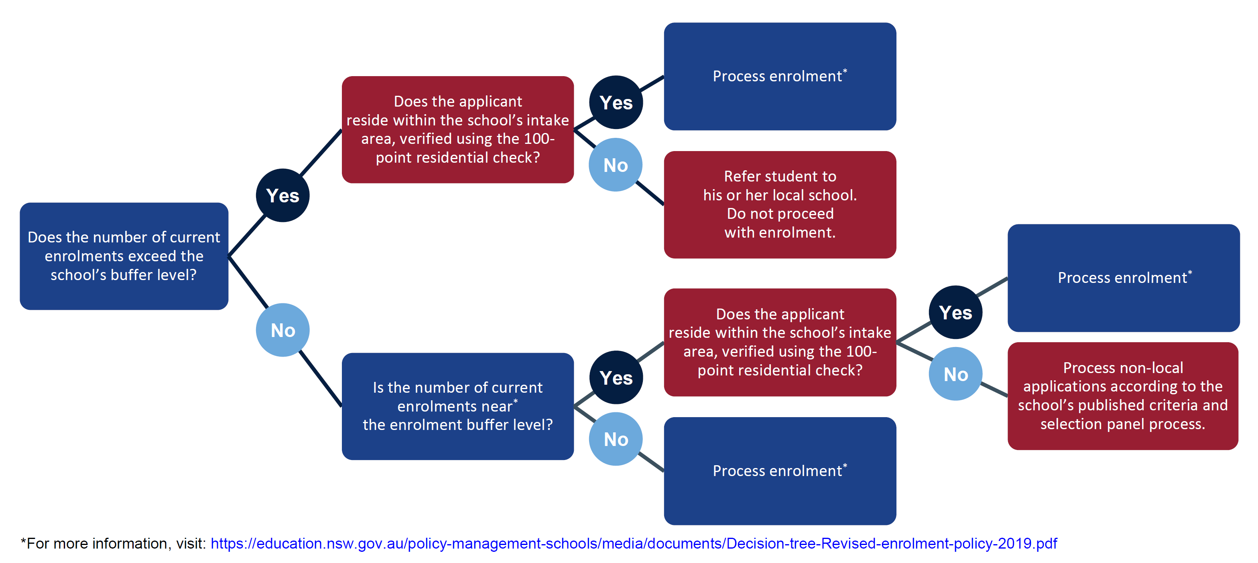](https://education.nsw.gov.au/policy-management-schools/media/documents/Decision-tree-Revised-enrolment-policy-2019.pdf)