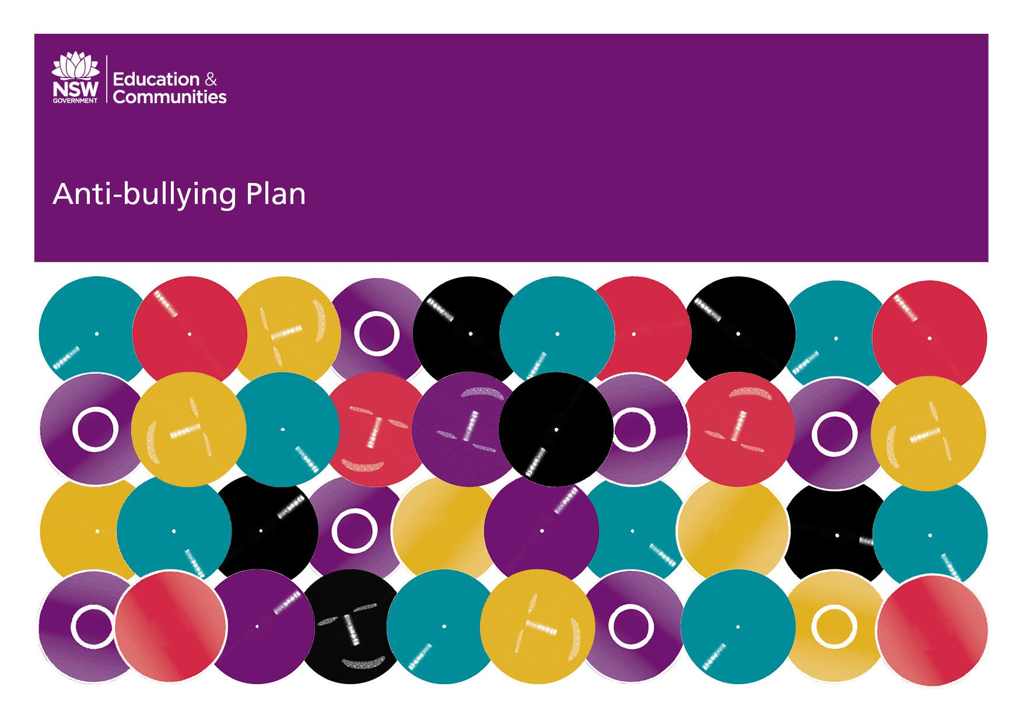

KINCUMBER PUBLIC SCHOOL 2017

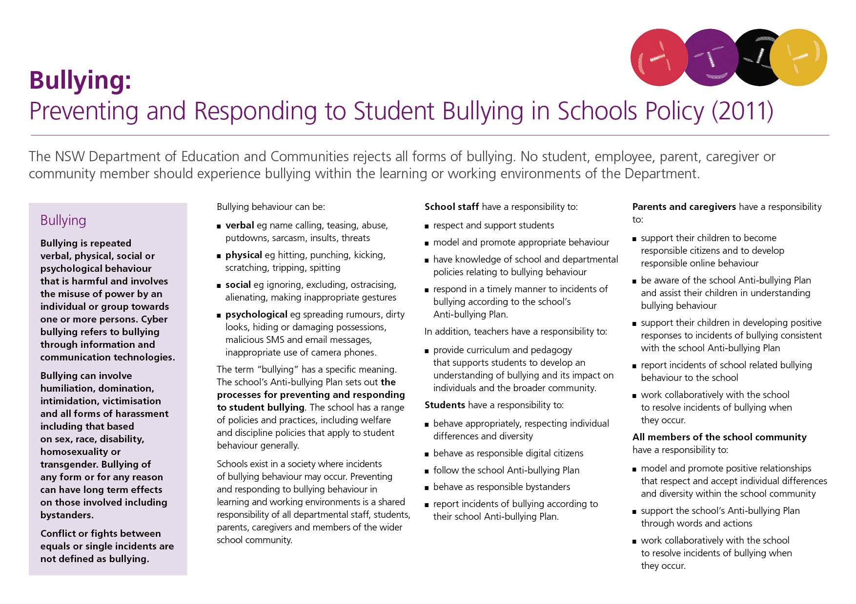

Our School Anti-Bullying Plan
This plan outlines the processes for preventing and responding to student bullying in our school and reflects the Bullying: Preventing and Responding to Student Bullying in Schools Policy of the New South Wales Department of Education and Communities.
This plan outlines the processes for preventing and responding to student bullying in our school and reflects the BULLYING: PREVENTING AND RESPONDING TO STUDENT BULLYING IN SCHOOLS POLICY (2011) of the Department of Education and Communities.

Statement of purpose
Kincumber Public School works in active partnership with its community to maintain a welcoming and nurturing learning environment. At Kincumber Public School we believe we can inspire every child to participate positively in society. We focus on promoting excellence, opportunity and success for every student, every day. We value and strive to develop safe, respectful learners.

Protection
Bullying, including cyber-bullying, is repeated verbal, physical, social or psychological behaviour that is harmful and involves the misuse of power by an individual or group towards one or more persons. Cyber-bullying refers to bullying through information and communication technologies.
Bullying can involve humiliation, domination, intimidation, victimisation and all forms of harassment including that based on sex, race, disability, homosexuality or transgender. Bullying of any form or for any reason can have long-term effects on those involved including bystanders.
Conflict or fights between equals or single incidents are not defined as bullying. “In around 20% of cases there’s an element of provocation from the perceived victim toward the bullies.” (Rigby)
A positive school culture which fosters student connection with both the school and the wider community will support the development of protective factors such as relationships, knowledge and skills.

To maintain a positive climate of respectful relationships where bullying is less likely to occur, we will:
- model and promote appropriate behaviour;
- develop a positive and pro-social school culture by reinforcing the school rules of
Be safe, be Respectful, be a learner;
- facilitate discussions about bullying and harassment within classes to promote a culture of respect and support;
- encourage students who have experienced bullying and students who have witnessed bullying in the past to positively participate in class discussions so that there is an understanding of how others feel;
- reinforce continually to all students that bullying is unacceptable and that behaving respectfully towards others is an expected part of school life.

Prevention
- whole school wellbeing programs such as You Can Do it which reinforces resilience, confidence, persistence, organisation and getting along skills.
- Social skills programs which promote life skills and social skills, assertiveness, resolution of difficult situations and communication skills.
- the Child Protection Program
- the Drug Education Program
- the Buddy System
- developing positive Student Leadership roles
- maintaining an active Learning Support Team

Early Intervention
Counsellor support will be offered to students who are identified as being at risk of developing long-term difficulties with social relationships. Counsellor support will also be offered to those students who are identified at or after enrolment as having previously experienced bullying or having engaged in bullying behavior.
Students can expect that their concerns will be responded to immediately by school staff once the staff have been informed by the student, parent or another staff member.

Response

Process for teachers dealing with a report of bullying:
  - Gather information about the incident.
  - Determine whether the report is of bullying, poor social skills or conflict.
  - Determine whether the incident is one-off or ongoing.
  - Record the incident including date, time, location, children involved and details of the incident in SENTRAL. This will prompt a notification to the Principal, Assistant Principal and Class Teacher of those involved.
  - Decide on the appropriate process for addressing the issue. Intervention methods used at Kincumber PS include COPING sessions, restrictions on play area, playground cards, CICO cards, redirection to other groups, restorative practices, mediation where the situation is ambiguous, providing strategies for the student involved and teaching students about bystander expectations. Involvement of the school counsellor is also an optional support.
  - Make a judgement on whether to refer the incident to the Assistant Principal and/or Principal, based on the seriousness of the incident or repeated involvement of a particular child.
A response will occur the same or following day (or as soon as time permits) after receiving the report. Within a week, contact should be made with the parents of the student who has experienced bullying to provide an update, within the bounds of privacy legislation.

Supporting the student who has experienced an incident involving bullying
There are a number of strategies and programs to support students who have been affected by, engaged in or witnessed bullying behaviour:
- Opportunities are provided for students to voice their concerns and formulate solutions, such as class meetings, Circle Time, individual approaches between teacher and student and during COPING sessions.
- A referral to the School Counsellor for an individual child may be initiated by a parent or teacher.
- The School Counsellor/stage assistant principal may implement a social skills development group if appropriate.
- Playground supervision will include encouraging isolated students to join a group and reminding students of strategies to deal with conflict.

Communication
The Anti-Bullying Plan will be presented at a P&C meeting for discussion and ratification.
Once ratified, the school community will be informed in the school newsletter that the plan has been placed on the school web-site.
Using SENTRAL, the Executive team will monitor and evaluate the effectiveness of its Anti-bullying Plan. The school will report annually at a P&C meeting on the effectiveness of the Anti-bullying Plan.

Review
This plan will be reviewed every three years. The next review is due by the end of 2020. Data used to evaluate the effectiveness of the plan could include:
- Incident reports, complaints and discipline referrals involving bullying of any type.
- Parent complaints about bullying
- Reports of playground incidents – nature, location and number
- Tell Them From Me Student Survey data
- Referrals to the school Learning Support Team for students who are identified as being at risk of developing long-term difficulties with social relationships or have experienced bullying or engaged in bullying behaviour.

Additional Information
The seriousness of the incident will be evaluated, especially incidents involving assaults, threats, intimidation or harassment.

Further responses may include:
- A report by the principal to the Child Wellbeing Unit or Department of Community Services
- Contact with the Youth Liaison Officer at Gosford Police (Ph 4323 5599)
- A report to Gosfrod Police (Ph 4323 5599)
- Contact with the Kids Helpline 1800 551 800

APPEAL PROCEDURES
Students and parents may appeal if they consider that correct procedures have not been followed, and/or that an unfair decision has been reached. Phone Central Coast District Office: 43489100.
While most complaints can be resolved informally, there are provisions for the use of formal procedures depending on the nature and seriousness of the complaint. The Complaints Handling Guidelines sets out the framework for a professional response according to the seriousness of the suggestion, complaint or allegation.

Principal’s comment
All members of the school community share a responsibility to create a school culture of care and respect for one another where individual differences are appreciated, understood and accepted. Children have a right to a school environment which helps them to feel safe, respected and to be uninterrupted from their learning experiences. In preparing children to grow into responsible citizens with the capacity to contribute positively and productively to our society, schools must equip them with strategies to identify and respond to bullying behaviour and to avoid becoming a bully. An important focus of our strategy is to empower the by-stander.
The executive team has overall responsibility for Student Wellbeing and the preparation of this policy. They are:
Karen Wardlaw Principal (Relieving)
David Logue – Assistant Principal
Sue Groom – Assistant Principal
Marilyn Laws – Assistant Principal
Kylie McGavin– Assistant Principal (relieving)
School contact information
Kincumber Public School
Avoca Drive Kincumber 2251
Ph: 4369 1544
Fax: 4369 2963
Email: Kincumber-p.school@det.nsw.edu.au
Web: http://www.Kincumber-p.schools.nsw.edu.au

